Design your UI to display the water turbidity,pH values

| DATE | 17 NOVEMBER 2022 |
| --- | --- |
| TEAM ID | PNT2022TMID26825 |
| PROJECT NAME | Real – Time River Water Quality Monitoring and Control System |
| MAXIMUM MARKS | 4 Mks |

1. Double-click the tab with the flow name, and call it Earthquake Details.
2. Click the hamburger menu, and then click Manage palette. Look for node-red-node- open weather map to install these additional nodes in your palette.

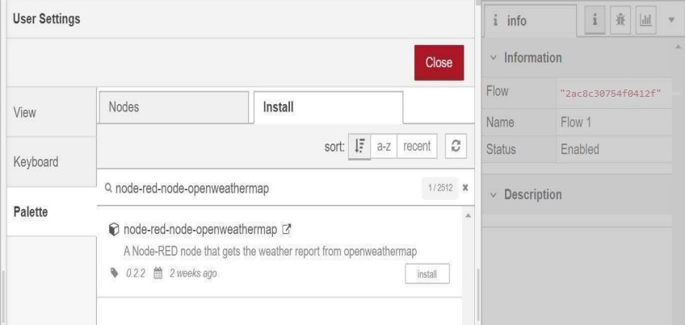

Add an HTTP input node to your flow.

Double-click the node to edit it. Set the method to GET and set the URL to /earthquakeinfo-hr.

* 1. Add an HTTP response node, and connect it to the previously added HTTP input node. All other nodes introduced in this sub-section is to be added between the HTTP input node and the HTTP response node.
  2. Add an HTTP request node and set the URL to

https://earthquake.usgs.gov/earthquakes/feed/v1.0/summary /all_hour.geojson, the Method to GET and the Return to a parsed JSON object. This will allow extracting all earthquakes that occurred within the last hour. Name this node Get